Real-Time Crowd Detection for Overcrowding Management Using OpenCV and pyttsx
Roopa R¹[0009-0002-3640-2645] , Swetha Thammisetty²[0009-0003-4747-5716] , Samba Siva Gajjala³[0009-0004-0791-8540] , Ravi Teja P⁴[0009-0005-7751-3749] , Reddy Chandra Kumar T ⁵[0009-0004-9289-6680] , Sanjana K 6[0009-0008-8712-5362]
^{1,2,3,4,5,6} Madanapalle Institute of Technology & Science, Madanapalle, Andhra Pradesh, India
¹roopa509@gmail.com,²swethathammisetty7@gmail.com, ³sambasivagajjala@gmail.com, ⁴tejapuchaginjala@gmail.com, ⁵chandrakumartulasi@gmail.com,⁶sanjana19477@gmail.com
Abstract: The persistent challenge of overcrowding in public spaces during events and festivals necessitates innovative solutions for efficient crowd management. In this paper, we propose a real-time crowd detection system employing OpenCV and pyttsx3. Our proposed system offers a practical and efficient solution for overcrowding management, providing real-time insights and alerts to facilitate timely interventions in public spaces. The system utilizes Haar cascade classifiers within OpenCV for accurate and rapid identification of pedestrians and upper bodies in video streams. The project initiates by initializing essential components, including a video capturing device, and enters a processing loop where frames are continuously analyzed. The integration of OpenCV and pyttsx3 showcases the synergy between computer vision and audio feedback, contributing to enhanced crowd surveillance and control during various events.
Keywords: Real-time object detection, Video processing, Pedestrian and full body detection, Alert mechanism, OpenCV application
- Introduction
The proposed real-time crowd detection system, integrating OpenCV and pyttsx3, presents a robust solution for managing large crowds in public spaces and events. This system aims to address the pressing need for efficient crowd monitoring to ensure public safety and event organization. By merging advanced computer vision techniques with auditory feedback capabilities, the system provides a comprehensive approach to crowd management. Central to the system’s functionality is the utilization of OpenCV’s Haar cascade classifiers for real-time object detection. Specifically, these classifiers enable the precise identification of pedestrians and upper body features in video streams, facilitating the accurate tracking of individuals and groups within crowded environments. Continuous analysis and tracking mechanisms further enhance the system’s capabilities by enabling the differentiation between single individuals and groups, as well as tracking their movements in real-time. This functionality allows for proactive crowd management measures to be implemented promptly as potential overcrowding situations arise. Integration of pyttsx3, a text-to-speech library, extends the system’s communication capabilities. When crowd density surpasses predefined thresholds, the system triggers voice messages and auditory alerts, providing stakeholders with additional sensory cues to complement visual feedback. The user interface of the system offers real-time visualization of critical crowd metrics, including the number of individuals, line length, and status updates. This interface empowers event planners and security personnel to actively monitor crowds and respond effectively to emerging situations. In summary, the multi-faceted approach adopted by the real-time crowd detection system, combining computer vision with auditory feedback and real-time visualization, offers a comprehensive solution for managing overcrowding. Further exploration of the system’s technical aspects, development methodology, and performance results will be detailed in subsequent sections of the research paper, demonstrating its potential impact on enhancing public safety and event management practices.

- RELATED WORK
Maniruzzaman et al. [19] presented a hypothetical Network of Everything (IoT)-based diabetics self-monitoring system which employs BLE devices to collect vital data, such blood glucose and weight. Using MongoDB for data storage and Apache Kafka for streaming messages and data, the system examines data in real time. The system’s goals are to supply suggestions, treatment, and results to manage diabetes.Cappon et al. [19] evaluated the characteristics of currently in use commercial versions of CGM wearable sensors and also prototypes. A method for using mobile phones and smartwatches to track blood glucose, exercise, insulin injections, and nutritional data is described by Arsand et al. [19]. In an effort to efficiently handle the conditions of diabetic patients, Lee and Yoo 4 generated an arrangement that makes use of a PDA to track their blood pressure, blood glucose levels, food consumption, and routines of exercise. Rodriguez et al. [19] proposed a smartphone application that uses an automated glucometer to gather data from sensors. They also discussed the possibility of using big data analysis from sensors to address issues related to diabetes. Several academic institutions, like the School of Computer Sciences at University Sains Malaysia and the School of Computing and Engineering at the University of West London, are associated with Muhammad Ashir Ali et al. [19] Hafiz Husnain Raza Sherazi, Sukumar Letchmunan, and Umair Muneer Butt are the corresponding authors. In their research paper, J. I. Su´arez et al. [19] talked about using cellphones and a Bluetooth gas detecting module to monitor air quality.The study article 12 discusses gathering vital health information, such as weight, blood pressure, blood glucose, and heartbeat, from sensors such BLE wireless devices. Realtime processing of this data and demographic data is used to monitor health conditions and predict the risk of diabetes. A variety of approaches and strategies for tracking and identifying humans, such as particle filtering framework for multiperson tracking-by-detection, HOG-based head-shoulder recognition, and statistical features of facial skin colour. Additionally, they learnt how to apply CNNs and SVMs, two deep learning and machine learning techniques, for object detection. Furthermore, students learned how to train Haar cascade classifiers for human detection and evaluate the separation between people when using Raspberry Pi and OpenCV-Python for crowd control. Syed Ameer Abbas, M. Anitha, and X. Vinitha Jaini’s ”Realisation of Multiple Human Head Detection and Direction Movement Using Raspberry Pi”: This study focuses on recognising human heads and counting the number of individuals in a particular region using OpenCV-Python and a Raspberry Pi 3 board. The authors of ”People Counting System using Raspberry Pi” are Shim Jaechang and Md. Israfil Ansari. This study suggests utilising a Raspberry Pi and OpenCV-Python combination to create a low-cost method of tracking and counting people based on blob recognition. Jaysri Thangam, Padmini Thupalli Siva, and B. Yogameena’s article ”Crowd Video Count in Low Resolution Surveillance Head Detector and Colour based using Segmentation for Disaster Management” This study counts the number of individuals in a crowd, especially when there is occlusion, by using a colorbased segmentation technique and a general head detector.[13] Kanchan Mangrule, H. T., ”Literature Survey of IoT Capable Crowd Analysis Using Raspberry Pi-3”: Insights into IoTenabled crowd analysis with a Raspberry Pi-3 are presented in this study, emphasising the significance of controlling and monitoring big gatherings in real time.[13] Using technologies like YOLOv5 and DeepSort, the project focuses on creating software for item detection, person tracking, and crowd counting. From YOLOv2 to YOLOv5, the YOLO (You Only Look Once) algorithm has improved, with YOLOv5 reaching greater frames per second (FPS) than YOLOv4. The system makes use of PyTorch for deep learning tasks, Tkinter for UI creation, and OpenCV for image processing and camera access. Obstacles in Crowd Analysis: Obstacles in crowd analysis include low resolution, intra- and inter-scene variations, excessive clutter, contrast variations, uneven people distribution, and uneven lighting. Current Methods for Crowd Analysis: Li et al. examined various techniques for crowd scene analysis, including crowd motion pattern learning, crowd behaviour, activity analysis, and anomaly detection in crowds. Zhan et al. and Junior et al. investigated and reviewed current methods for general crowd analysis. Comparing Crowd Counting Techniques: Loy et al. provide a thorough explanation and analysis of crowd counting techniques based on video pictures, emphasising how successful CNN-based techniques are at lowering error rates. Methods for the Crowd Detection System: Three main categories of methods can be used to categorise the methods: detection-based, regression-based, and density-based. Detection-Based Approaches: Detection-based approaches use simultaneous identification of individuals and their locations in order to estimate the population. For this, a variety of techniques and algorithms have been employed, including the Adaboost learning algorithm and the scanning window pedestrian detector. Regression-Based Methods: Regression-based methods extract feature mappings for crowd counting by working on local picture patches. For crowd counting, many characteristics are used, such as the Local Binary Pattern (LBP), the Histogram of Oriented Gradients (HOG), and regression approaches including neural networks and linear regression. Crowd Counting Systems: These systems use a variety of techniques, including regression-based estimation and detection, to identify and categorise people in crowd scenes before using classifiers to count them.
- METHODOLOGY
  - Opencv
OpenCV, brief for Open Source Computer Vision Library, is an open-source computer vision and machine learning program library. It was initially created by Intel in 1999 and has since ended up one of the foremost broadly utilized libraries for real-time computer vision applications. OpenCV is composed in C++ and offers interfacing for C++, Python, Java, and MATLAB, making it available to a wide gathering of people of developers.
The library gives a comprehensive set of apparatuses and calculations for different assignments in computer vision, picture handling, and machine learning. A few of the key highlights of OpenCV include:
Picture Preparing: OpenCV offers a wealthy set of capacities for fundamental and progressed picture preparing errands, such as sifting, changes, color space transformations, and geometric operations.
Question Discovery and Acknowledgment: It incorporates pre-trained models and calculations for question discovery, acknowledgment, and following. Procedures like Haar cascades, Hoard (Histogram of Arranged Angles), and profound learning-based strategies are supported.
Highlight Discovery and Portrayal: OpenCV gives capacities for recognizing and portraying key highlights in pictures, such as corners, edges, and keypoints. These highlights are significant for assignments like picture coordinating, stereo vision, and 3D reconstruction.
Machine Learning Integration: OpenCV consistently coordinating with prevalent machine learning systems like TensorFlow, PyTorch, and scikit-learn. It permits clients to construct and prepare custom models for different computer vision errands, counting classification, relapse, and clustering.
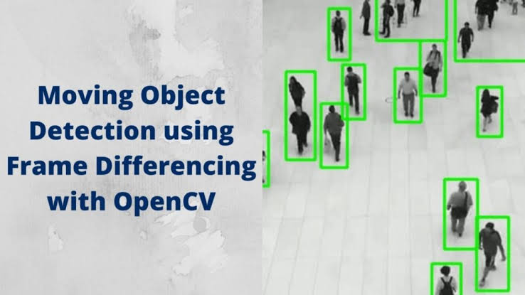
Fig. 1. Example Image of OpenCV
Table 1. OPEN CV
Component | Requirement
OpenCV Version | Compatible with system setup and dependencies.
Compiler | Visual Studio(Windows),GCC(Linux),etc.
GPU | NVDIA GPU with CUDA support(for GPU acceleration).
Dependencies | GTK,ffmpeg.
Python Packages | OpenCV,Numpy,Matplotlib,etc.

Camera Calibration and 3D Remaking: The library incorporates apparatuses for camera calibration, stereo vision, and 3D recreation, empowering applications like expanded reality, structure from movement, and profundity sensing.
Cross-Platform Compatibility: OpenCV is cross-platform and runs on different working frameworks counting Windows, Linux, macOS, Android, and iOS. This permits designers to send their applications over distinctive stages with ease.
  - Pyttsp
A bundle called PyTTSPy might be intended for text-tospeech (TTS) integration. It provides an easy-to-use interface for converting written text into spoken language. PyTTS includes a variety of features, including the ability to choose from a variety of voices, adjust the speech rate, and create sound recordings from input content. It makes use of various TTS motors and APIs, promot2ing flexibility in selecting the preferred blend technique. PyTTSPy is a useful tool for engineers that allows them to easily integrate text-to-speech functionality into their projects.

  - Haarcascade Classifier
Haar Cascade classifiers are a machine learning-based approach utilized for question discovery in pictures or recordings. They are especially prevalent for recognizing objects like faces, eyes, and other predefined designs. The strategy was presented by Paul Viola and Michael Jones in their seminal paper in 2001.
Here’s a brief depiction of how Haar Cascade classifiers work:
Include Choice: Haar-like highlights are rectangular channels that are connected to an picture to extricate important data. These highlights are comparable to convolutional bits but are less complex and computationally efficient. Preparing: At first, a Haar Cascade classifier is prepared employing a expansive number of positive and negative samples. Positive tests are pictures containing the target question (e.g., faces), whereas negative tests are pictures that don’t contain the protest. Amid preparing, the classifier learns to recognize between positive and negative tests by recognizing designs within the Haar-like features.
Cascade of Classifiers: The prepared classifier comprises of different stages organized in a cascade design. Each arrange comprises of a few powerless classifiers, which are straightforward choice capacities that classify a locale of the picture as either containing the question or not. The cascade structure permits for early dismissal of locales that are improbable to contain the protest, in this manner progressing efficiency.
Necessarily Picture: To speed up the computation of Haarlike highlights, an integral picture representation of the input picture is utilized. This representation permits for quick calculation of rectangular highlights at diverse scales and positions.
Sliding Window: The classifier is connected to the input picture employing a sliding window approach. The window moves over the picture, and at each position, the classifier assesses whether the locale inside the window contains the protest of interest.
Thresholding and Classification: The yield of each weak classifier is combined to form a final choice around whether the question is show within the locale being inspected. This choice is based on a edge, which is decided amid training. Haar Cascade classifiers are broadly utilized in different applications, counting confront discovery in photos, facial acknowledgment frameworks, pedestrian detection in independent vehicles, and more. They offer a adjust between precision and computational productivity, making them appropriate for real-time applications. In any case, they may not perform well beneath challenging conditions such as occlusions, varieties in lighting, or changes in scale.

- PROPOSED WORK
  - Modules

Initialization: For auditory notifications, the script initialises a text-to-speech engine (using pyttsx3). Using OpenCV, Haar cascades for full-body and pedestrian detection are loaded.
Video Capture: Using a given source (in this example, a video file called ”pep.mp4”), the script records video frames.
Detection and Tracking: To facilitate effective processing, the collected frames are transformed to grayscale. Haar cascades with parameters for scale factor, minimum neighbours, and minimum size are used to detect pedestrians and entire bodies. The bounding box area of each detected individual is used to group them, with larger groupings being given preference.
Grouping and Alerting: Using a predetermined threshold (group-threshold), the script keeps an eye out for the emergence of crowds. The text-to-speech engine generates and plays a message when it detects a crowd. For recognised groups, a visual sign is also shown on the video frames.
Queue Management: An area of interest that is designated as a ”queue-area” by the script is where individuals are tracked independently. On the video frames, the queue size is computed and shown as a status.
User Interface: The video stream shows visual information such as the number of people, the length of the queue, and alarm messages. In an OpenCV window, the video feed with the overlayed data is continuously displayed. User Interaction:Hitting the ’q’ key will end the script.

  - ARCHITECTURE
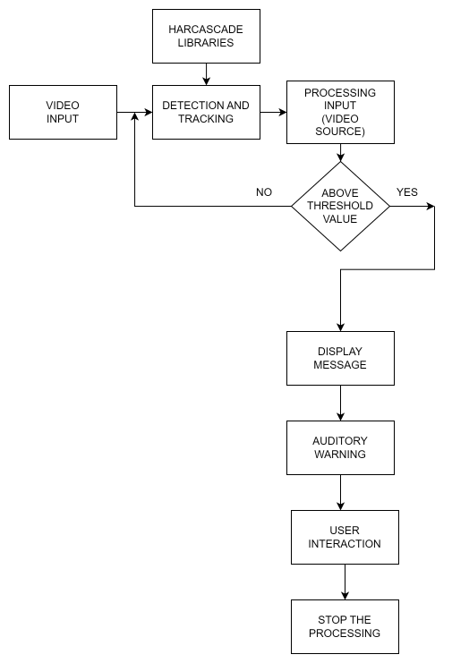
Fig 2. Architecture of Proposed Model
- RESULT AND DISCUSSION
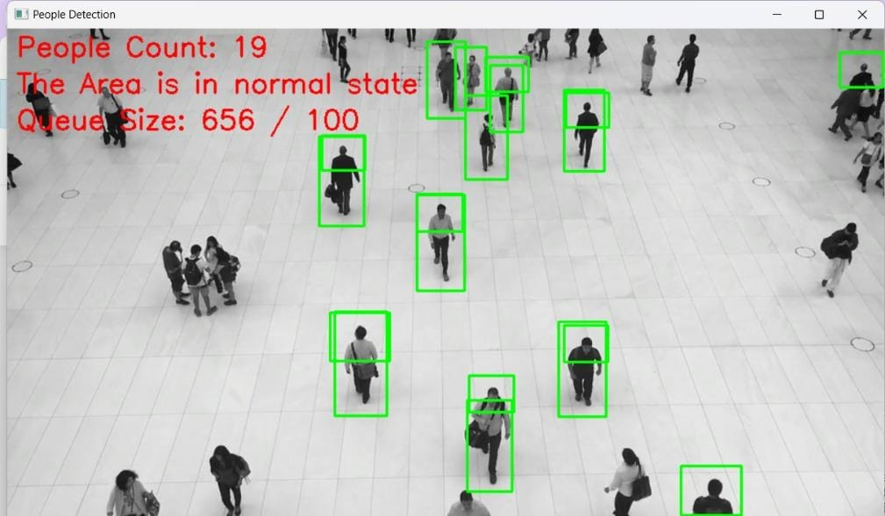
Fig 3. Normal State
The results in Figures 3 and 4 showcase the Real-Time Crowd Detection system’s functionality, recognizing people through green rectangular boxes and actively monitoring their count. Pre-recorded people count demonstrates the system’s ability to display the number of individuals within the monitored area. The green boxes affirm the effectiveness of the crowd detection algorithm. Utilizing a threshold value, the system triggers on-screen text messages when the people count exceeds, indicating overcrowding, and employs pyttsx3 for voice alerts. Conversely, when the count is below the threshold, a normal state message is displayed. This dynamic system responds effectively to varying crowd densities, offering a comprehensive approach to crowd management with visual, on-screen, and voice alerts. These results set the stage for enhanced safety and crowd control measures in diverse environments.
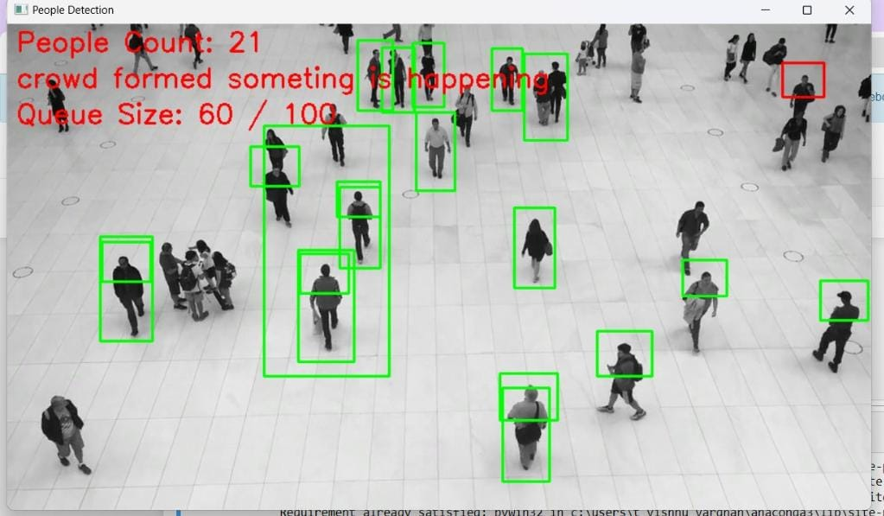
Fig 4. Crowded State
Figure 5 demonstrates the Real-Time Crowd Detection system’s live video features, presenting insights on people count and response mechanisms. The real-time counting of individuals in the live video feed provides immediate and dynamic crowd density information. Human recognition is visually highlighted through green rectangular boxes, showcasing the system’s proficiency in identifying people. Utilizing a threshold for live people count, the system triggers onscreen text messages and voice alerts via pyttsx3 upon surpassing the threshold, indicating overcrowding. Voice messages complement on-screen alerts, efficiently notifying users or authorities. When the people count is below the threshold, a normal state message reassures that the monitored area is stable. This real-time responsiveness, coupled with visual, onscreen, and voice alerts, contributes to a comprehensive crowd management approach. The integration of live video analysis further enhances the system’s effectiveness, establishing a robust foundation for improved safety and control measures in real-world environments.
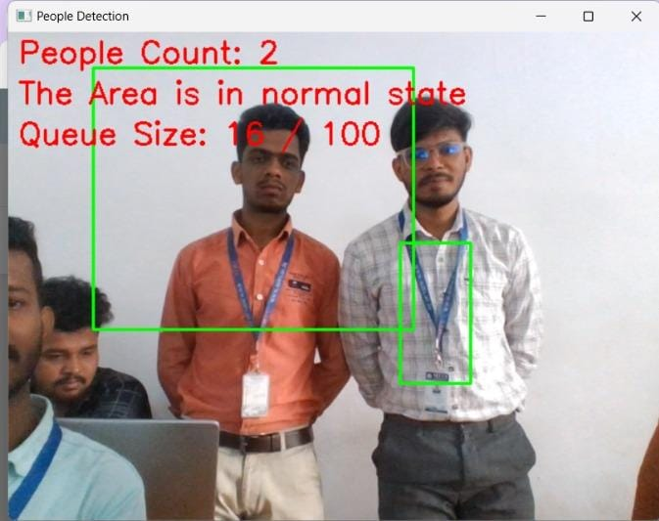
Fig 5. Real Time Example
- CONCLUSION
The proposed system proves effective in dynamically monitoring crowds. The threshold-based alert system, complemented by visual indicators and voice alerts, ensures prompt response to potential overcrowding. The system’s accurate human recognition and real-time adaptability make it a valuable tool for crowd management. With the potential for further enhancements, it lays a strong foundation for improving safety
measures in diverse environments. Overall, the integration of computer vision and audio notifications demonstrates practical applications for real-world crowd control.

- FUTURE SCOPE
The future scope of Real-Time Crowd Detection using OpenCV and pyttsx3 holds promising avenues for advancement. Integration with cutting-edge technologies such as edge computing and IoT will enhance real-time processing and data collection capabilities, providing a more comprehensive understanding of crowd dynamics. Further development of advanced machine learning models can empower the system to predict and proactively manage crowd behavior, ensuring a more intelligent approach to overcrowding management. Expanding the capabilities of the mobile application, with features like real-time alerts and collaborative reporting, will foster greater user engagement and contribute to a more interactive crowd management ecosystem. Additionally, incorporating geospatial mapping for spatial visualization and continuous optimization for performance will solidify the system’s position at the forefront of innovative solutions, contributing to improved safety and efficiency in managing crowded environments.

- ACKNOWLEDGMENT
We would like to extend our sincere gratitude to Madanapalle Institute of Technology and Science for the resources and support provided during the development of the Real-Time Crowd Detection for Overcrowding Management Using OpenCV and pyttsx. Our profound thanks to Mrs. Roopa.R and Dr. S. Kusuma for their invaluable guidance, and our team members for their voluntary contributions. Warm acknowledgment from colleagues at the Department of Data science for their collaboration.

REFERENCES
- CG Abhinu, P Aswin, Kiran Krishnan, Bonymol Baby, and KS Angel Viji. Multiple object tracking using deep learning with yolo v5. International Journal of Engineering Research & Technology, 9(13):4751, 2021.
- Laith Alzubaidi, Jinglan Zhang, Amjad J Humaidi, Ayad Al-Dujaili, Ye Duan, Omran Al-Shamma, Jose Santamar ´ ´ıa, Mohammed A Fadhel, Muthana Al-Amidie, and Laith Farhan. Review of deep learning: Concepts, cnn architectures, challenges, applications, future directions. Journal of big Data, 8:1–74, 2021.
- Md Israfil Ansari and Jaechang Shim. People counting system using raspberry pi. Journal of Multimedia Information System, 4(4):239–242, 2017.
- Michael D Breitenstein, Fabian Reichlin, Bastian Leibe, Esther KollerMeier, and Luc Van Gool. Online multiperson tracking-by-detection from a single, uncalibrated camera. IEEE transactions on pattern analysis and machine intelligence, 33(9):1820–1833, 2010.
- Mayur D Chaudhari and Archana S Ghotkar. A study on crowd detection and density analysis for safety control. International journal of computer sciences and engineering, 6:424–428, 2018.
- Lijia Deng, Shui-Hua Wang, and Yu-Dong Zhang. Fully optimized convolutional neural network based on small-scale crowd. In 2020 IEEE International Symposium on Circuits and Systems (ISCAS), pages 1–5. IEEE, 2020.
- Zizhu Fan, Hong Zhang, Zheng Zhang, Guangming Lu, Yudong Zhang, and Yaowei Wang. A survey of crowd counting and density estimation based on convolutional neural network. Neurocomputing, 472:224–251, 2022.
- Min Fu, Pei Xu, Xudong Li, Qihe Liu, Mao Ye, and Ce Zhu. Fast crowd density estimation with convolutional neural networks. Engineering Applications of Artificial Intelligence, 43:81–88, 2015.
- Haroon Idrees, Imran Saleemi, Cody Seibert, and Mubarak Shah. Multisource multi-scale counting in extremely dense crowd images. In Proceedings of the IEEE conference on computer vision and pattern recognition, pages 2547–2554, 2013.
- Hasith Karunasekera, Han Wang, and Handuo Zhang. Multiple object tracking with attention to appearance, structure, motion and size. IEEE Access, 7:104423–104434, 2019.
- Min Li, Zhaoxiang Zhang, Kaiqi Huang, and Tieniu Tan. Estimating the number of people in crowded scenes by mid based foreground segmentation and head-shoulder detection. In 2008 19th international conference on pattern recognition, pages 1–4. IEEE, 2008.
- Songyan Ma and Tiancang Du. Improved adaboost face detection. In 2010 International Conference on Measuring Technology and Mechatronics Automation, volume 2, pages 434–437. IEEE, 2010.
- Yunqi Miao, Jungong Han, Yongsheng Gao, and Baochang Zhang. Stcnn: Spatial-temporal convolutional neural network for crowd counting in videos. Pattern Recognition Letters, 125:113–118, 2019.
- Davidson Kamala Dhas Milton and Arun Ra Velraj. Crowd size estimation and detecting social distancing using raspberry pi and opencv. International Journal of Electronics and Telecommunications, 69, 2023.
- Viet-Quoc Pham, Tatsuo Kozakaya, Osamu Yamaguchi, and Ryuzo Okada. Count forest: Co-voting uncertain number of targets using random forest for crowd density estimation. In Proceedings of the IEEE international conference on computer vision, pages 3253–3261, 2015.
- Chong Shang, Haizhou Ai, and Bo Bai. End-to-end crowd counting via joint learning local and global count. In 2016 IEEE International Conference on Image Processing (ICIP), pages 1215–1219. IEEE, 2016.
- Li Tan, Xu Dong, Yuxi Ma, and Chongchong Yu. A multiple object tracking algorithm based on yolo detection. In 2018 11th International Congress on Image and Signal Processing, BioMedical Engineering and Informatics (CISP-BMEI), pages 1–5. IEEE, 2018.
- Qi Wang, Junyu Gao, Wei Lin, and Xuelong Li. Nwpu-crowd: A largescale benchmark for crowd counting and localization. IEEE transactions on pattern analysis and machine intelligence, 43(6):2141–2149, 2020.
- Qi Wang, Junyu Gao, Wei Lin, and Yuan Yuan. Learning from synthetic data for crowd counting in the wild. In Proceedings of the IEEE/CVF conference on computer vision and pattern recognition, pages 8198– 8207, 2019.
- Yi Wang, Junhui Hou, Xinyu Hou, and Lap-Pui Chau. A self-training approach for point-supervised object detection and counting in crowds. IEEE Transactions on Image Processing, 30:2876–2887, 2021.
- Yi Wang, Xinyu Hou, and Lap-Pui Chau. Dense point prediction: A simple baseline for crowd counting and localization. In 2021 IEEE International Conference on Multimedia & Expo Workshops (ICMEW), pages 1–6. IEEE, 2021.
- Xing Wei, Yuanrui Kang, Jihao Yang, Yunfeng Qiu, Dahu Shi, Wenming Tan, and Yihong Gong. Scene-adaptive attention network for crowd counting. arXiv preprint arXiv:2112.15509, 2021.
- Shaokai Wu and Fengyu Yang. Boosting detection in crowd analysis via underutilized output features. In Proceedings of the IEEE/CVF Conference on Computer Vision and Pattern Recognition, pages 15609– 15618, 2023.
- Mingliang Xu, Zhaoyang Ge, Xiaoheng Jiang, Gaoge Cui, Pei Lv, Bing Zhou, and Changsheng Xu. Depth information guided crowd counting for complex crowd scenes. Pattern Recognition Letters, 125:563–569, 2019.
- Binyu Zhang, Yunhao Du, Yanyun Zhao, Junfeng Wan, and Zhihang Tong. I-mmccn: Improved mmccn for rgb-t crowd counting of drone images. In 2021 7th IEEE International Conference on Network Intelligence and Digital Content (IC-NIDC), pages 117–121. IEEE, 2021.
- Cong Zhang, Hongsheng Li, Xiaogang Wang, and Xiaokang Yang. Cross-scene crowd counting via deep convolutional neural networks. In Proceedings of the IEEE conference on computer vision and pattern recognition, pages 833–841, 2015.

